#### Guest Access in Teams

Now comes the important part. To enable guest access in Teams you need to first enable guest access in Azure AD, second on Office 365 Groups settings and finally on individual Teams. From the Teams admin centre, you can check the number of guests on each team.

## **Step 1: Turn on guest access at the Teams org-wide level**

To turn on guest access, go to the Teams admin center at <https://admin.teams.microsoft.com>

1. In the Teams admin center, select **Org-Wide settings** > **Guest access**.
2. Set the **Allow guest access in Microsoft Teams** switch to **On**.

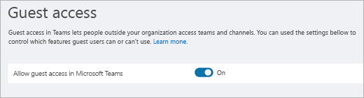

1. On this same page, turn on or turn off **Calling**, **Meeting**, and **Messaging** settings for guests.
2. Click **Save**.

## **Step 2: Configure Microsoft 365 Groups**

1. In the Microsoft 365 admin center, go to **Settings** > **Settings**, click **Services**, and then select **Microsoft 365 Groups**.

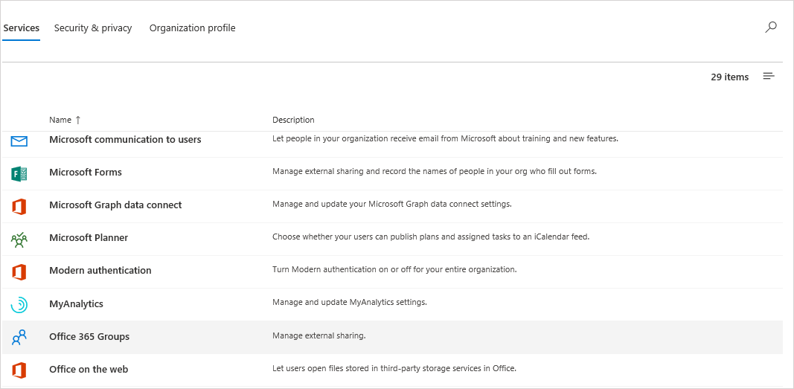

1. Make sure that the **Let group members outside the organization access group content** check box is selected. If this setting is not selected, guests won't be able to access any group content.

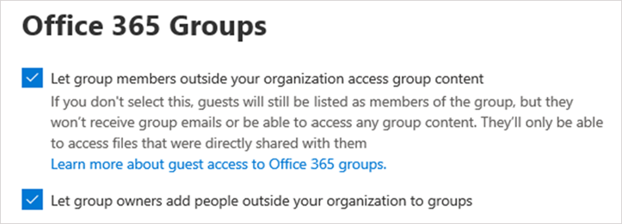

1. Make sure that the **Let group owners add people outside the organization to groups** check box is selected. If this setting is not selected, team owners won't be able to add new guests. At a minimum, this setting must be on to support guest access.

## **Step 3: Configure sharing in Office 365**

Make sure that users can add guests. Here's how:

1. In the Microsoft 365 admin center, go to **Settings** > **Settings**, click **Security & privacy**, and then select **Sharing**.

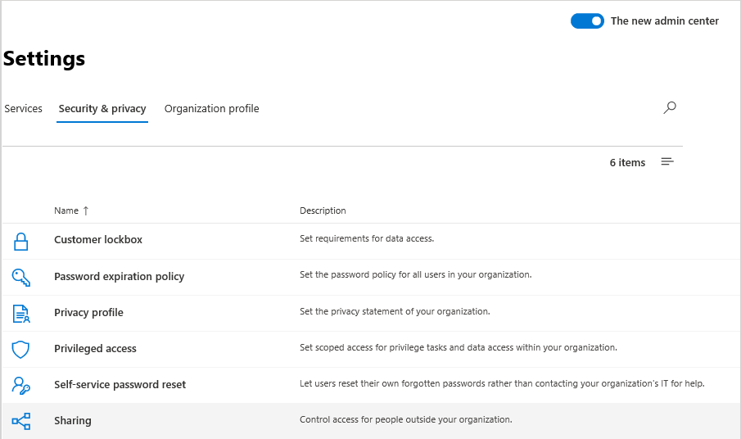

1. Select the **Let users add new guests to this organization** check box, and then click **Save changes**.

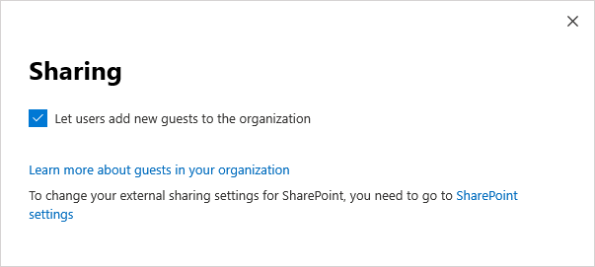

Note : This setting is equivalent to the **Members can invite** setting in **User settings** > **External users** in Azure AD.

## **Step 4: Verify sharing setting in SharePoint**

1. Sign into the Microsoft 365 admin center.
2. Under **Admin centers**, select **SharePoint**.
3. In the new SharePoint admin center, under **Sites**, select **Active sites**.

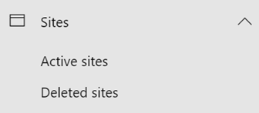

1. Select the site, and then click **Sharing**.
2. Make sure that the option is set to **Anyone** or **New and existing guests**.

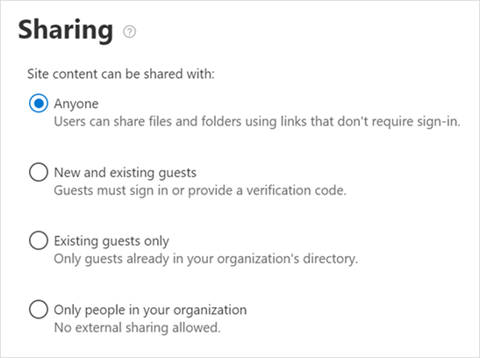

## **Step 6: Set up guest user permissions**

In the Teams application, at the individual team level, configure guest permissions that control whether guests can create, update, or delete channels. Teams admins as well as team owners can configure these settings.

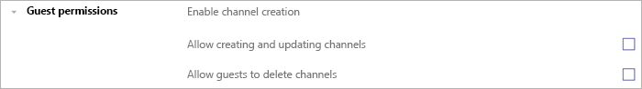

You can control the guest permissions on Teams meeting and messaging from the Teams Admin centre.  
<https://admin.teams.microsoft.com/company-wide-settings/guest-configuration>